**R46CA01 modbus rtu protocol**

Function code

|  |  |  |  |  |
| --- | --- | --- | --- | --- |
| RS485 address  (Station address)  (1) | Function (1) | Register address (2) | Read number (2) | CRC16 (2) |
|  | 03 Read |  |  |  |
|  | 06 Write |  |  |  |

|  |  |  |  |  |
| --- | --- | --- | --- | --- |
| Read-only register,Read Function code Is 03 | | | | |
| Register address | Register contents | Number of bytes | Units | Remarks |
| 0x0000 | Temperature value | 2 | 0.1℃ | When the data is 0X8000(32768),  it indicates no sensor or error |
| Read / write register; Read function code is 03 ,Write function code is 06 | | | | |
| 0x0002 | RS485 address  (Station address) | 2 |  | Read Address 0XFF  Write Address 1-247 |
| 0x0003 | Baud rate | 2 |  | 0~4 0:1200  1:2400 2:4800  3:9600（default）  4:19200  5: Factory reset |
| 0x0004 | Temperature correction value | 2 | 0.1℃ | >0 Temperature increase  <0 temperature decrease  Default : 0 |

**Serial baud rate：9600（**default**），N，8，1**

**Modbus RTU Communication protocol：**

1. **Read temperature**

Send data

|  |  |  |  |  |
| --- | --- | --- | --- | --- |
| RS485 address  (Station address)  (1) | Function (1) | Register address (2) | Read number (2) | CRC16(2) |

Returns data

|  |  |  |  |  |
| --- | --- | --- | --- | --- |
| RS485 address  (Station address)  (1) | Function (1) | Number of bytes (1) | data (n) | CRC16(2) |

Function code 0x03

Register address：0x0000

Read number：0x0001

The return of the temperature data is two bytes，High-bit in the former and low-bit in the post，convert it to decimal and divided by 10, is the current temperature value；The highest bit 1 indicates a negative value， this value directly subtracting 65536，is the current temperature value.

For example:

send data(RS485 address is 1)：01 03 00 00 00 01 84 0A

Returns data：01 03 02 00 DB F8 1F

01 RS485 address，03 Function，02 length，F8 1F crc16

00DB is the temperature value, the highest bit is 0, so the temperature is positive, it is converted to decimal = 219, 219/10=21.9 is the current temperature value；

Returns data：01 03 02 FF 90 F2 3F

FF90 is the temperature value, the highest bit is 1, so the temperature is negative, it is converted to decimal = 65424, (65424-65536)/10=-11.2 is the current temperature value

1. **Read RS485 address**

Send data

|  |  |  |  |  |
| --- | --- | --- | --- | --- |
| RS485 address  (Broadcast address)  (1) | Function (1) | Register address (2) | Read number (2) | CRC16(2) |

Returns data

|  |  |  |  |  |
| --- | --- | --- | --- | --- |
| RS485 address  ( Broadcast address )  (1) | Function (1) | Number of bytes (1) | data (n) | CRC16(2) |

Broadcast address 0xff

Function code 0x03

Register address：0x0002

Read number：0x0001

For example:

send data：FF 03 00 02 00 01 30 14

Returns data：FF 03 02 00 01 50 50

FF Broadcast address，03 Function，02 length，01 is the current module RS485 address , 50 50 crc16

Note: When using this command, only one temperature module can be connected to the RS485 bus, more than one will be wrong!

1. **Write RS485 address**

Send data

|  |  |  |  |  |
| --- | --- | --- | --- | --- |
| RS485 address  (Station address)  (1) | Function (1) | Register address (2) | Setting Content (2) | CRC16(2) |

Returns data

|  |  |  |  |  |
| --- | --- | --- | --- | --- |
| RS485 address  (Station address)  (1) | Function (1) | Register address  (2) | Register value (2) | CRC16(2) |

Function code 0x06

Register address：0x0002

Setting Content：2Bytes(1-247)

For example, The current RS485 address is 1, We need to change the RS485 address to 3:

send data(RS485 address is 1)：01 06 00 02 00 03 68 0B

Returns data：01 06 00 02 00 03 68 0B

1. **Read baud rate**

Send data

|  |  |  |  |  |
| --- | --- | --- | --- | --- |
| RS485 address  (Station address)  (1) | Function (1) | Register address (2) | Read number (2) | CRC16(2) |

Returns data

|  |  |  |  |  |
| --- | --- | --- | --- | --- |
| RS485 address  (Station address)  (1) | Function (1) | Number of bytes (1) | data (n) | CRC16(2) |

Function code 0x03

Register address：0x0003

Read number：0x0001

For example:

send data(RS485 address is 1)：01 03 00 03 00 01 74 0A

Returns data：01 03 02 00 03 F8 45

01 RS485 address，03 Function，02 length，38 F1 crc16

03 means the current baud rate is 9600bps

Baud rate corresponds to the number: 0: 1200 1: 2400 2: 4800 3: 9600 4: 19200

1. **Write RS485 address**

Send data

|  |  |  |  |  |
| --- | --- | --- | --- | --- |
| RS485 address  (Station address)  (1) | Function (1) | Register address (2) | Setting Content (2) | CRC16(2) |

Returns data

|  |  |  |  |  |
| --- | --- | --- | --- | --- |
| RS485 address  (Station address)  (1) | Function (1) | Register address  (2) | Register value (2) | CRC16(2) |

Function code 0x06

Register address：0x0003

Setting Content：2Bytes(0-4)

For example, Change the baud rate to 4800bps:

send data(RS485 address is 1)：01 06 00 03 00 02 F8 0B

Returns data：01 06 00 03 00 02 F8 0B

Baud rate corresponds to the number: 0: 1200 1: 2400 2: 4800 3: 9600 4: 19200

5: Factory reset

Note: 1 The baud rate will be updated when the module is powered up again!

2 The factory setting can be restored when the baud rate corresponding to the number is 5. For example: 01 06 00 03 00 05 B9 C9

1. **Read the temperature correction value:**

Send data

|  |  |  |  |  |
| --- | --- | --- | --- | --- |
| RS485 address  (Station address)  (1) | Function (1) | Register address (2) | Read number (2) | CRC16(2) |

Returns data

|  |  |  |  |  |
| --- | --- | --- | --- | --- |
| RS485 address  (Station address)  (1) | Function (1) | Number of bytes (1) | data (n) | CRC16(2) |

Function code 0x03

Register address：0x0004

Read number：0x0001

Return data: Celsius, you need to divide this value by 10.

The temperature sensor may have an error with the actual temperature. This correction value can correct the error. The unit is 0.1 °C. If the correction value is a positive number, the value is added at the current temperature, and if it is a negative number, the value is subtracted. Setting it to 0 disables this feature.

For example 1:

send data(RS485 address is 1)：01 03 00 04 00 01 C5 CB

Returns data：01 03 02 00 64 B9 AF

0064 is the correction value, which is expressed as decimal in 100, divided by 10 = 10.0 ° C;

For example 2:

send data(RS485 address is 1)：01 03 00 04 00 01 C5 CB

Returns data：01 03 02 FF F1 38 30

FF F1 is the correction value, which is expressed as decimal in -15, divided by 10 = -1.5° C;

1. **Set the temperature correction value**

If the temperature of the module deviates from the actual temperature, it can be corrected with this value. >0 temperature increases, <0 temperature decreases.

Send data

|  |  |  |  |  |
| --- | --- | --- | --- | --- |
| RS485 address  (Station address)  (1) | Function (1) | Register address (2) | Setting Content (2) | CRC16(2) |

Returns data

|  |  |  |  |  |
| --- | --- | --- | --- | --- |
| RS485 address  (Station address)  (1) | Function (1) | Register address  (2) | Register value (2) | CRC16(2) |

Function code 0x06

Register address：0x0004

Setting Content：2Bytes

The highest digit indicates a positive or negative sign, 0 indicates positive, and 1 indicates negative, and the unit is 0.1 °C. When the highest bit is 1, it indicates a negative value. In this case, you need to add 1 to this value. You can also subtract 65536 from the value, which is the current temperature value. Prohibit the correction value to set the register to "0X0000"

For example 1: offset value is set to 2.0 °C

Send frame: 01 06 00 04 00 14 C8 04

Return frame: 01 06 00 04 00 14 C8 04 The return frame is the same as the send frame.

For example 2: the offset value is set to -3.0 ° C, 65536-30 = 65506 =0XFFE2

Send frame: 01 06 00 04 FF E2 09 B2

Return frame: 01 06 00 04 FF E2 09 B2 The return frame is the same as the send frame.

For example 3: Prohibit the correction value and set the register to "0X0000"

Send frame: 01 06 00 04 00 00 C8 0B

Return frame: 01 06 00 04 00 00 C8 0B The return frame is the same as the send frame.

MODBUS commands you can use "Modbus Poll" input, as shown below

（CRC check generated automatically）

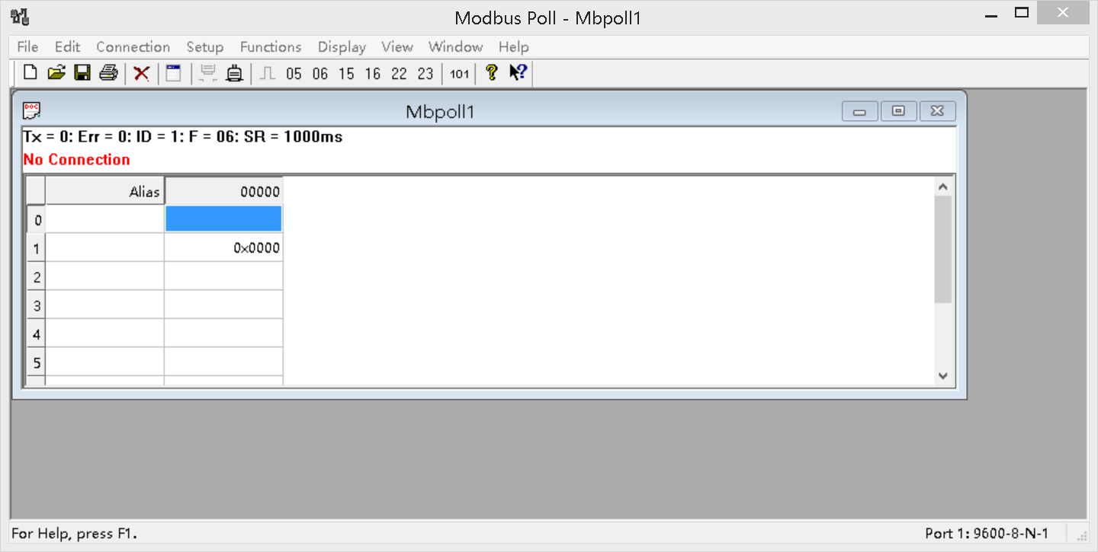

You can also use HyperTerminal serial input, as shown below

（Manually add CRC check）

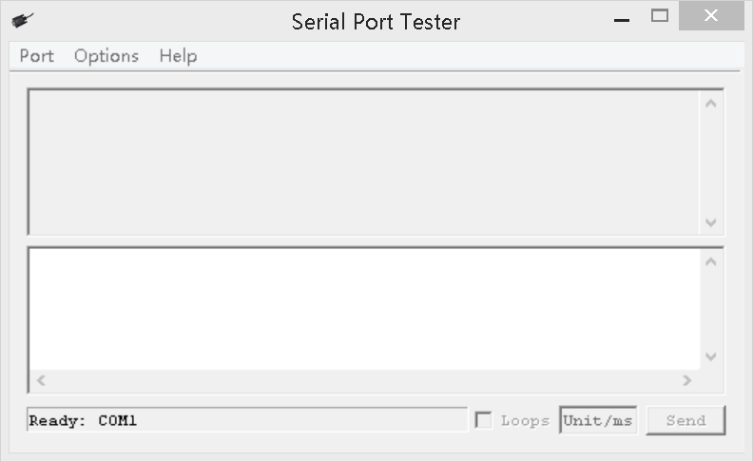

**CRC check code(C51 MCU)：**

const unsigned char code auchCRCHi[256] = {

0x00, 0xC1, 0x81, 0x40, 0x01, 0xC0, 0x80, 0x41, 0x01, 0xC0, 0x80, 0x41, 0x00, 0xC1, 0x81, 0x40,

0x01, 0xC0, 0x80, 0x41, 0x00, 0xC1, 0x81, 0x40, 0x00, 0xC1, 0x81, 0x40, 0x01, 0xC0, 0x80, 0x41,

0x01, 0xC0, 0x80, 0x41, 0x00, 0xC1, 0x81, 0x40, 0x00, 0xC1, 0x81, 0x40, 0x01, 0xC0, 0x80, 0x41,

0x00, 0xC1, 0x81, 0x40, 0x01, 0xC0, 0x80, 0x41, 0x01, 0xC0, 0x80, 0x41, 0x00, 0xC1, 0x81, 0x40,

0x01, 0xC0, 0x80, 0x41, 0x00, 0xC1, 0x81, 0x40, 0x00, 0xC1, 0x81, 0x40, 0x01, 0xC0, 0x80, 0x41,

0x00, 0xC1, 0x81, 0x40, 0x01, 0xC0, 0x80, 0x41, 0x01, 0xC0, 0x80, 0x41, 0x00, 0xC1, 0x81, 0x40,

0x00, 0xC1, 0x81, 0x40, 0x01, 0xC0, 0x80, 0x41, 0x01, 0xC0, 0x80, 0x41, 0x00, 0xC1, 0x81, 0x40,

0x01, 0xC0, 0x80, 0x41, 0x00, 0xC1, 0x81, 0x40, 0x00, 0xC1, 0x81, 0x40, 0x01, 0xC0, 0x80, 0x41,

0x01, 0xC0, 0x80, 0x41, 0x00, 0xC1, 0x81, 0x40, 0x00, 0xC1, 0x81, 0x40, 0x01, 0xC0, 0x80, 0x41,

0x00, 0xC1, 0x81, 0x40, 0x01, 0xC0, 0x80, 0x41, 0x01, 0xC0, 0x80, 0x41, 0x00, 0xC1, 0x81, 0x40,

0x00, 0xC1, 0x81, 0x40, 0x01, 0xC0, 0x80, 0x41, 0x01, 0xC0, 0x80, 0x41, 0x00, 0xC1, 0x81, 0x40,

0x01, 0xC0, 0x80, 0x41, 0x00, 0xC1, 0x81, 0x40, 0x00, 0xC1, 0x81, 0x40, 0x01, 0xC0, 0x80, 0x41,

0x00, 0xC1, 0x81, 0x40, 0x01, 0xC0, 0x80, 0x41, 0x01, 0xC0, 0x80, 0x41, 0x00, 0xC1, 0x81, 0x40,

0x01, 0xC0, 0x80, 0x41, 0x00, 0xC1, 0x81, 0x40, 0x00, 0xC1, 0x81, 0x40, 0x01, 0xC0, 0x80, 0x41,

0x01, 0xC0, 0x80, 0x41, 0x00, 0xC1, 0x81, 0x40, 0x00, 0xC1, 0x81, 0x40, 0x01, 0xC0, 0x80, 0x41,

0x00, 0xC1, 0x81, 0x40, 0x01, 0xC0, 0x80, 0x41, 0x01, 0xC0, 0x80, 0x41, 0x00, 0xC1, 0x81, 0x40

} ;

const unsigned char code auchCRCLo[256] = {

0x00, 0xC0, 0xC1, 0x01, 0xC3, 0x03, 0x02, 0xC2, 0xC6, 0x06, 0x07, 0xC7, 0x05, 0xC5, 0xC4,0x04,

0xCC, 0x0C, 0x0D, 0xCD, 0x0F, 0xCF, 0xCE, 0x0E, 0x0A, 0xCA, 0xCB, 0x0B, 0xC9, 0x09, 0x08, 0xC8,

0xD8, 0x18, 0x19, 0xD9, 0x1B, 0xDB, 0xDA, 0x1A, 0x1E, 0xDE, 0xDF, 0x1F, 0xDD, 0x1D, 0x1C, 0xDC,

0x14, 0xD4, 0xD5, 0x15, 0xD7, 0x17, 0x16, 0xD6, 0xD2, 0x12, 0x13, 0xD3, 0x11, 0xD1, 0xD0, 0x10,

0xF0, 0x30, 0x31, 0xF1, 0x33, 0xF3, 0xF2, 0x32, 0x36, 0xF6, 0xF7, 0x37, 0xF5, 0x35, 0x34, 0xF4,

0x3C, 0xFC, 0xFD, 0x3D, 0xFF, 0x3F, 0x3E, 0xFE, 0xFA, 0x3A, 0x3B, 0xFB, 0x39, 0xF9, 0xF8, 0x38,

0x28, 0xE8, 0xE9, 0x29, 0xEB, 0x2B, 0x2A, 0xEA, 0xEE, 0x2E, 0x2F, 0xEF, 0x2D, 0xED, 0xEC, 0x2C,

0xE4, 0x24, 0x25, 0xE5, 0x27, 0xE7, 0xE6, 0x26, 0x22, 0xE2, 0xE3, 0x23, 0xE1, 0x21, 0x20, 0xE0,

0xA0, 0x60, 0x61, 0xA1, 0x63, 0xA3, 0xA2, 0x62, 0x66, 0xA6, 0xA7, 0x67, 0xA5, 0x65, 0x64, 0xA4,

0x6C, 0xAC, 0xAD, 0x6D, 0xAF, 0x6F, 0x6E, 0xAE, 0xAA, 0x6A, 0x6B, 0xAB, 0x69, 0xA9, 0xA8, 0x68,

0x78, 0xB8, 0xB9, 0x79, 0xBB, 0x7B, 0x7A, 0xBA, 0xBE, 0x7E, 0x7F, 0xBF, 0x7D, 0xBD, 0xBC, 0x7C,

0xB4, 0x74, 0x75, 0xB5, 0x77, 0xB7, 0xB6, 0x76, 0x72, 0xB2, 0xB3, 0x73, 0xB1, 0x71, 0x70, 0xB0,

0x50, 0x90, 0x91, 0x51, 0x93, 0x53, 0x52, 0x92, 0x96, 0x56, 0x57, 0x97, 0x55, 0x95, 0x94, 0x54,

0x9C, 0x5C, 0x5D, 0x9D, 0x5F, 0x9F, 0x9E, 0x5E, 0x5A, 0x9A, 0x9B, 0x5B, 0x99, 0x59, 0x58, 0x98,

0x88, 0x48, 0x49, 0x89, 0x4B, 0x8B, 0x8A, 0x4A, 0x4E, 0x8E, 0x8F, 0x4F, 0x8D, 0x4D, 0x4C, 0x8C,

0x44, 0x84, 0x85, 0x45, 0x87, 0x47, 0x46, 0x86, 0x82, 0x42, 0x43, 0x83, 0x41, 0x81, 0x80,0x40

} ;

unsigned int CRC_16(unsigned char *str,unsigned int usDataLen)

{

unsigned char uchCRCHi = 0xFF ; /* high byte of CRC initialized */

unsigned char uchCRCLo = 0xFF ; /* low byte of CRC initialized */

unsigned uIndex ; /* will index into CRC lookup table */

while (usDataLen--)/* pass through message buffer */

{

uIndex = uchCRCHi ^ *str++ ; /* calculate the CRC */

uchCRCHi = uchCRCLo ^ auchCRCHi[uIndex];

uchCRCLo = auchCRCLo[uIndex] ;

}

return (uchCRCHi << 8 | uchCRCLo) ;

}